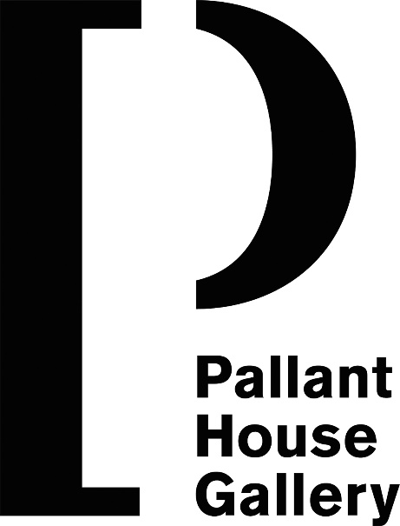

Drawn from Nature:
Gilbert White and the Artists
Contemporary Commissions

Garden Gallery

Alice Pattullo
b.1988
Selborne Church
2020
Screenprint on paper Courtesy of the Artist
Edition available from the Pallant Bookshop

Gilbert White was the curate of St Mary’s Church Selborne and is buried in the churchyard. Alice Pattullo shows the low tower surrounded by circling swifts, about which White often wrote.

Alice Pattullo
b.1988
Gilbert
2020
Screenprint on paper Courtesy of the Artist
Edition available from the Pallant Bookshop

Christopher Brown
b.1953
A Garden Pet
2020
Linocut on Zerkall paper Artist’s proof
Courtesy of the Artist
Edition available from the Pallant Bookshop

After studying at the Royal College of Art Christopher Brown assisted Edward Bawden who encouraged him to explore linocutting. He has recalled how: ‘returning from Cornwall one year, Bawden suggested a detour to Selborne. He would have done a great job illustrating the book. He was extremely fond of both the Nash and Ravilious editions.’

This linocut shows Gilbert White’s tortoise ‘Timothy’ which had originally been purchased from a Chichester sailor in the 1730s.

Jo Sweeting
b.1965
Hybernaculum Head
2020
Woodcut print on paper Courtesy of the Artist
Edition available from the Pallant Bookshop

Sweeting carved the ‘Hybernaculum Head’ as a response to Gilbert White’s works about swallows, house martins and swifts and their migration patterns. He felt certain, as Aristotle and Pliny did, that some of the later born birds chose not to migrate and instead remained in nooks, sand tunnels and hollow trees, hibernating. She has commented that: ‘This shows White observing birds in the landscape as an interior topography. White’s head as a cerebrum of sky. The hirundines’ flight lines of remembered symmetry etched in his mind.’

Michael Kirkman
b.1986
The most unusual birds
2020
Linocut on paper Courtesy of the Artist
Edition available from the Pallant Bookshop

Gilbert White commented that: ‘The most unusual birds I ever observed in these parts were a pair of hoopoes (upupa), which came several years ago in the summer, and frequented an ornamental piece of ground, which joins to my garden, for some weeks. They used to march about in a stately manner, feeding in the walks, many times in the day; and seemed disposed to breed in my outlet; but were frightened and persecuted by idle boys, which would never let them be at rest.’ (Letter XI, September 9, 1767)

Tristan Sherwood
b.1976
Likeness
2020
Hybrid woodcut and linocut print on paper Signed edition of 20
Courtesy of the Artist
Edition available from the Pallant Bookshop

Sherwood has commented: ‘This print explores the idea of the mimetic in both art and nature. The many editions of Gilbert White’s Natural History of Selborne have spawned numerous illustrative ‘incarnations’ of White’s cuckoo. This scenario formed a poetic motif, through which I could illustrate the nature of similitude. Making work ‘after’ another artist could be seen as equivalent to the parasitic nature of the cuckoo. Thomas Bewick, Eric Ravilious and Agnes Miller Parker are clearly informed by their antecedents, unlike the cuckoo itself it is their distinct interpretations which nestle their own birds within our mind’s eye.’

Emily Sutton
b.1983
Tortoise
2020
Watercolour and pencil on paper Courtesy the Artist

Clive Hicks-Jenkins
b.1951
Hare
2020
Pencil on paper Courtesy of the Artist

Mark Hearld
b.1974
Hoopoes
2020
Collage and gouache on paper in artist’s frame Courtesy of the Artist

Neil Bousfield
b.1967
Gilbert’s Tears
2020
Wood-engraving on paper (diptych) Courtesy of the Artist
Edition available from the Pallant Bookshop

Neil Bousfield has said: ‘The work I make investigates the idea of place and place making. As place is an emotional construct made from memory, personal experiences and values projected on to the landscape spaces we occupy, I was interested in making work that explored, past, present, narrative, and experience and these are the ideas that underpin the work ‘Gilbert’s Tears’. If Gilbert White was here today, the Attenborough of his time, he would mourn the predicted loss of the bumble bee, birds, the impact of climate change, loss of habitat, biodiversity, and would be in tears for what is now only beginning to dawn upon us. Gilbert White is more relevant now than ever.’

Emily Sutton
b.1983
White Owl
2020
Watercolour and pencil on paper Courtesy of the Artist

Ed Kluz
b.1980
The Hermitage
2020
Scraperboard Courtesy of the Artist

A scraperboard is a gesso panel with a black coating, which is scratched off to reveal the white beneath. It is a medium that was used by many illustrators in the 1930s and 1940s. This image is inspired by the oval half-title of the 1789 First Edition of the Natural History by Samuel Hieronymous Grimm (on display in the Print Room), which depicts Gilbert White’s gothic summerhouse on Selborne Hanger, a folly known as ‘the Hermitage’.

Clive Hicks-Jenkins
b.1951
Cockerel
2020
Pencil on paper Courtesy of the Artist

Mark Hearld
b.1974
Hare, Partridges and Pheasants
2020
Collage and gouache on paper in artist’s frame

In his fifth letter to Thomas Pennant, Gilbert White, declared: ‘The manor of Selborne... and all its sloping coverts, would swarm with game; and even now hares, partridges,
pheasants around; and in old days woodcock were a plentiful. There are few quails because they more affect open fields than enclosures; after harvest few landrails are seen.’

Alice Pattullo
b.1988
Timothy
2020
Screenprint on paper Courtesy of the Artist
Edition available from the Pallant Bookshop

Christopher Brown
b.1953
It hobbles towards its benefactress
2020
Linocut on Zerkall paper Artist’s proof
Courtesy of the Artist
Edition available from the Pallant Bookshop

Gilbert White was fascinated by the tortoise that belonged to his aunt Rebecca Snookes, who lived at Ringmer in Sussex, which he inherited. ‘As soon as the good old lady comes in sight who has waited on it for more than thirty years, it hobbles towards its benefactress with awkward alacrity; but remains inattentive to strangers. Thus not only “the ox knoweth his owner, and the ass his master’s crib,” but the most abject and torpid of beings distinguishes the hand that feeds it, and is touched with the feelings of gratitude!’ (Letter XIII, April 12th, 1772)

Angie Lewin
b.1963
Bird Cup
2020
Wood-engraving on paper Courtesy of the Artist
Edition available from the Pallant Bookshop

Clive Hicks-Jenkins
b.1951
Swan
2020
Pencil on paper Courtesy of the Artist

Gilbert White was fascinated by the development and mating habits of birds and wrote of how: ‘Swans turn white the second year, and breed the third.’ (Letter XL, Selborne, Sept 2nd, 1774)

