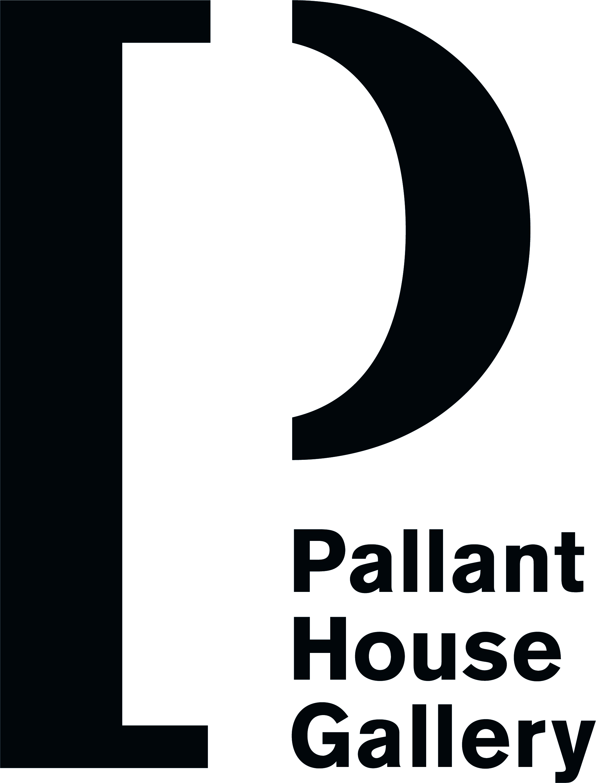

Community VOLUNTEER Application Form

Date:

Name:

Address:

Postcode:

Tel: Daytime Tel:
Email: Email:

Contact in case of emergency:
Relationship to you:
Address:

Tel:
Email:

Other key contacts:

Doctor:
Address:

Health needs: (medication, diet etc,)

Occupation:

What transport do you use?

If you have a car do you intend to use it for the scheme?

How did you find out about The Community Programme?

What time will you have available?

Any experience of people with support needs:

Interests, hobbies etc:

Art skills/knowledge:

Personal qualities:

What is your attraction to The Community Programme?

What are your expectations of being a volunteer?

We sometimes take photos and film different sessions and events. Are you happy for us to use images of you taking part in these activities for promotion, press and in exhibitions?
Yes
No

Note: You will need to do a DBS check through Pallant House Gallery after you have attended the volunteer Partners in Art Induction Training.

Please provide the names and addresses of two referees, one of whom has known you on a personal basis, who will be approached if you commit to the scheme.
Name: Name:
Address: Address:

Postcode: Postcode:

Please return this form to Community Programme Manager at Pallant House Gallery, 9 North Pallant, Chichester, West Sussex, PO19 1TJ.
Email: community@pallant.org.uk Phone: 07788 489536

