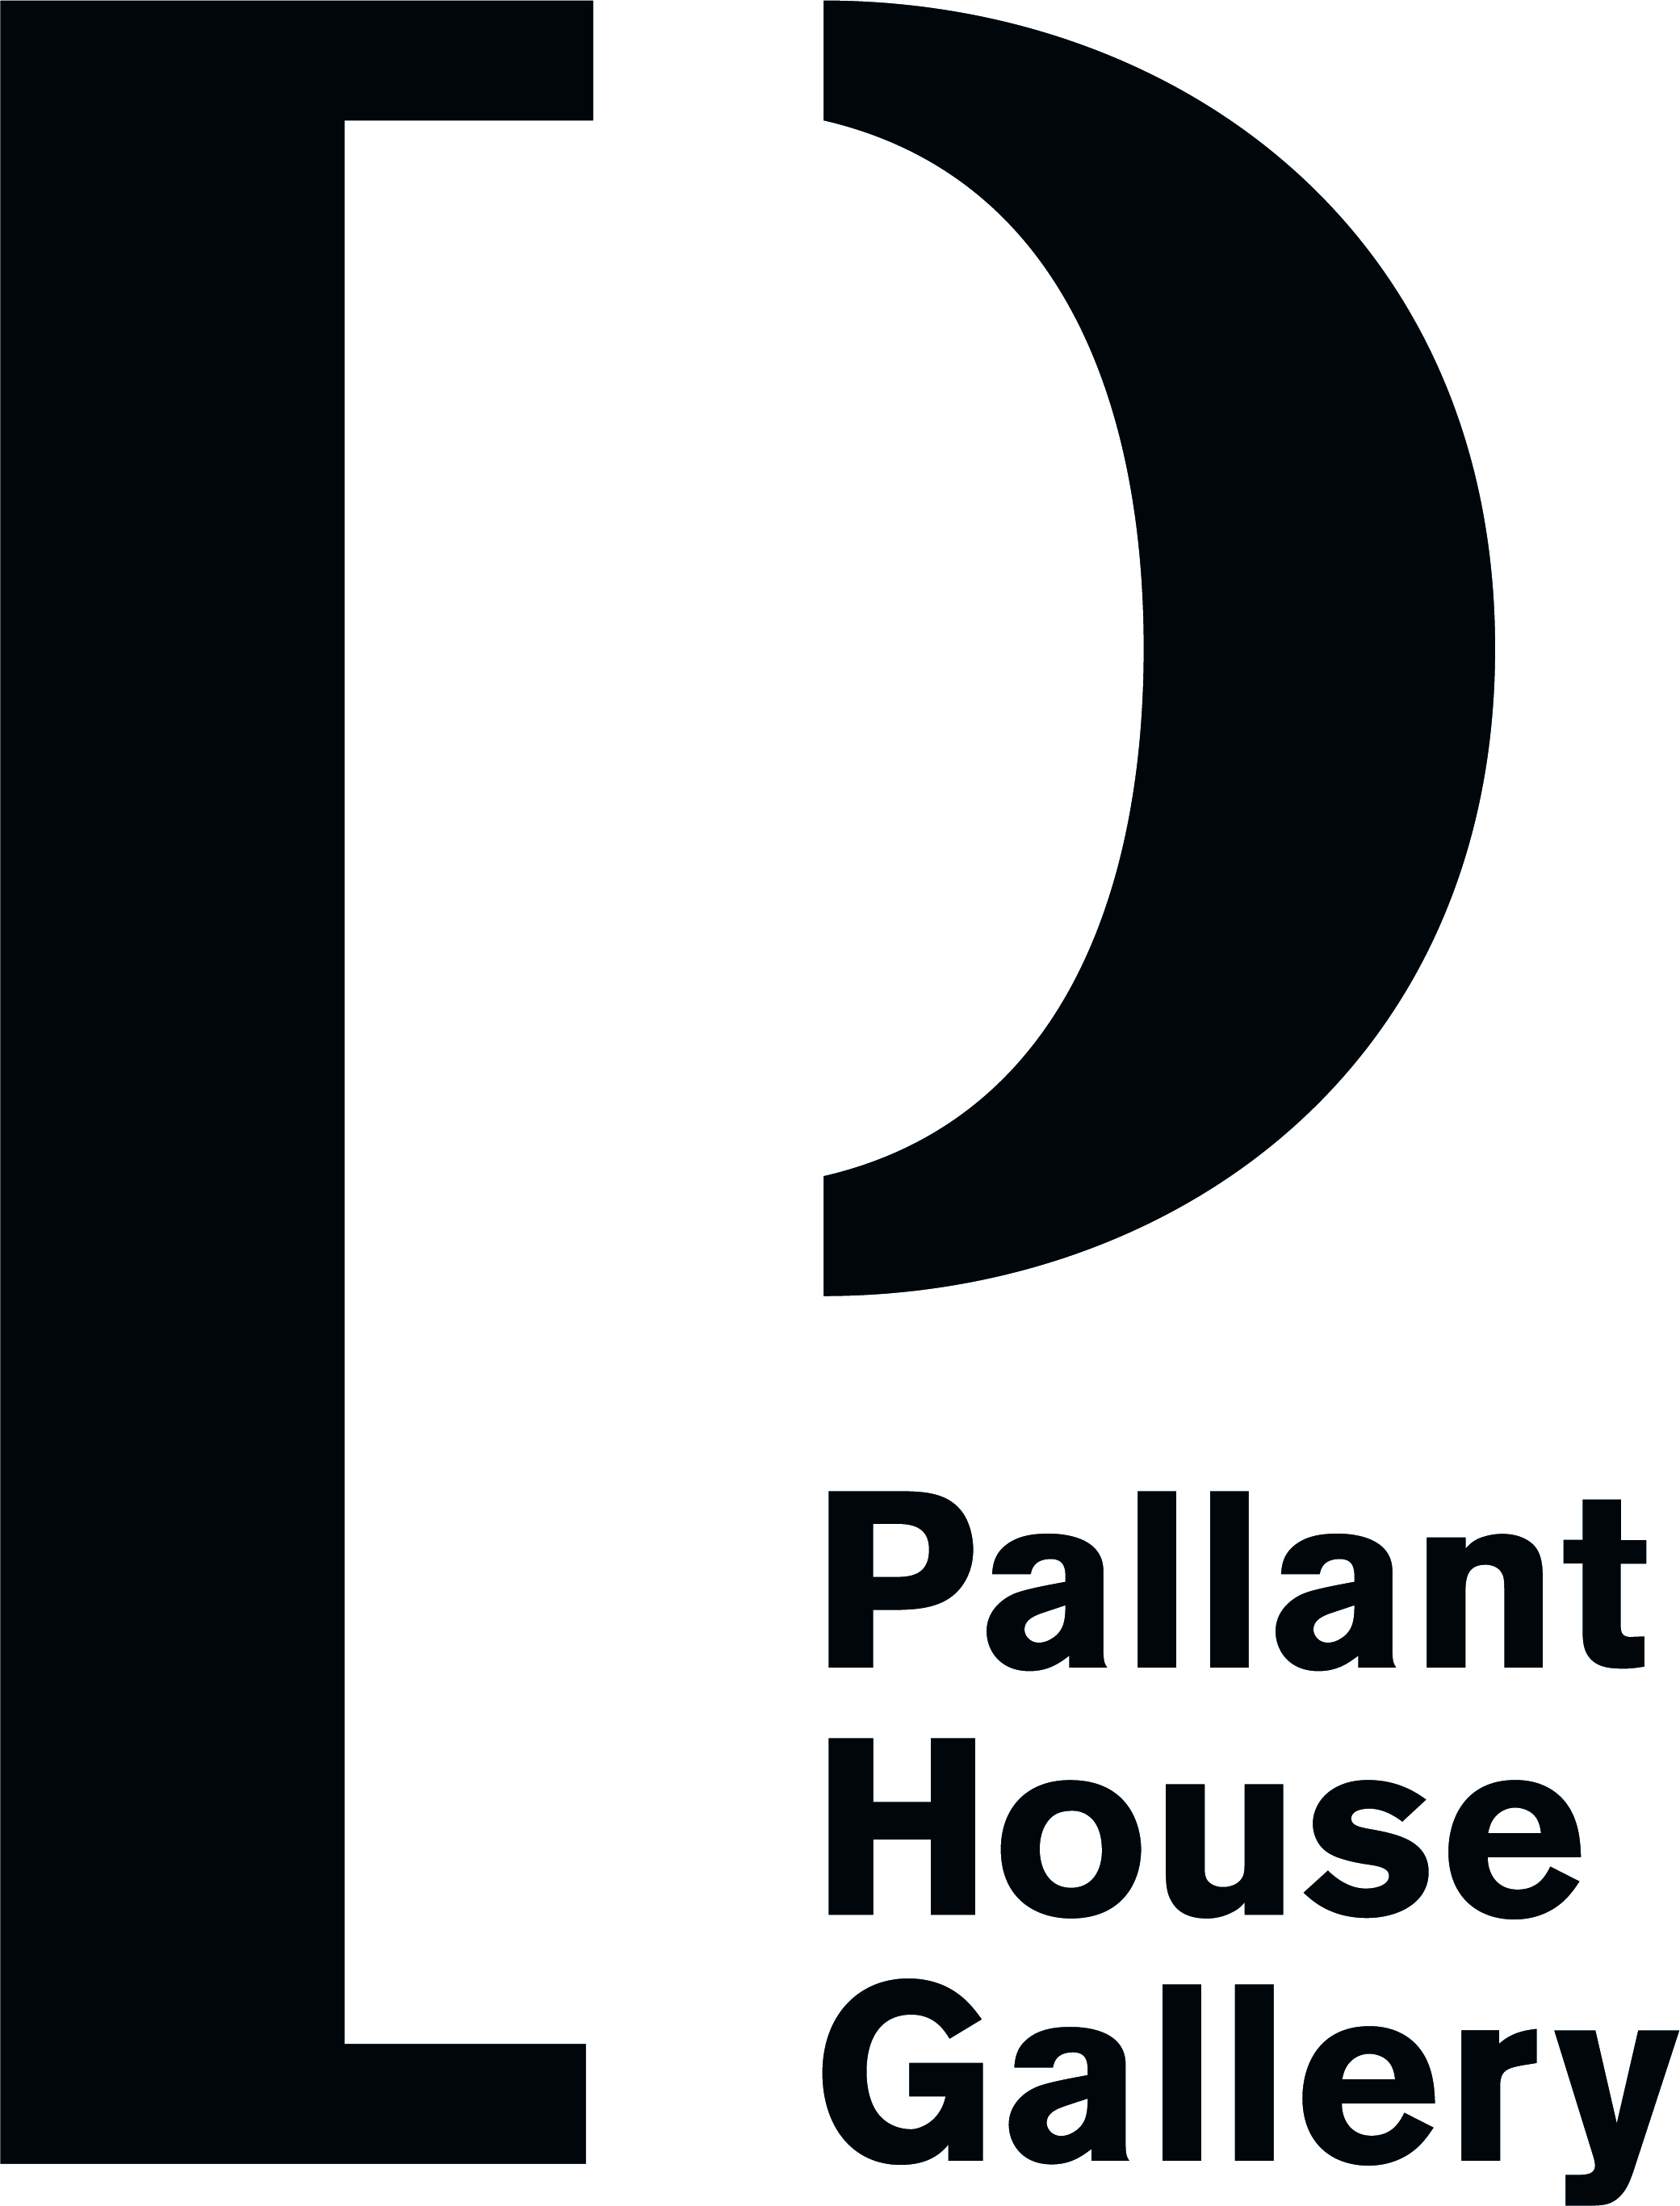

REFERRAL PARTNER INFORMATION

Name: Date:

Home address: Day time address:

Tel: Tel:
Email: Email:

Contact in case of emergency:
Name and address:

Tel:

Email:

Other key contacts: (e.g. social worker, key worker)

Doctor:
Address:
Tel:

Health needs: (medication, diet etc

Support needs:

Transport needs:

Occupation/time availability:
What are your interests in art?

What art skills do you have?

Interests, hobbies etc:

What do you hope for from joining the Partners in Art scheme?

How did you find out about Partners in Art?

Any other information or questions

We sometimes take photos and film different sessions and events. Are you happy for us to use images of you taking part in these activities for promotion, press and in exhibitions?
Yes
No

Please tick how you would best like us to contact you:
Text Message Email Call Post

Please return this form to:

Community Programme Manager
Pallant House Gallery
9, North Pallant
Chichester
PO19 1TJ

Email: community@pallant.org.uk Telephone: 07788489536

