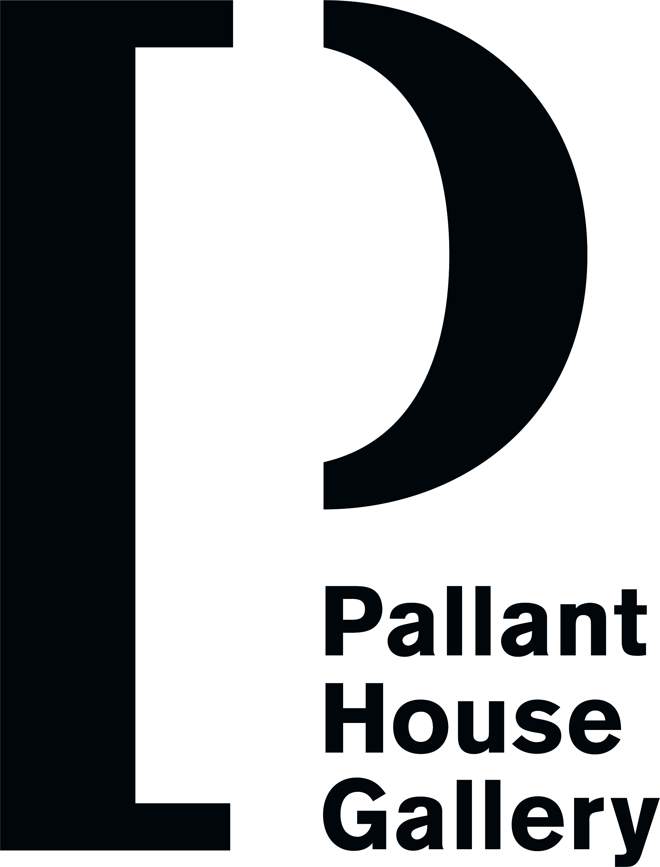

VOLUNTEER PARTNER Application Form

Name: Date:
Address:

Postcode:

Tel: Daytime Tel:
Email: Email:

Contact in case of emergency:
Relationship to you:
Address:

Tel:
Email:

Other key contacts:

Doctor:
Address:

Health needs: (medication, diet etc,)

Occupation:

What transport do you use?

If you have a car do you intend to use it for the scheme?

How did you find out about Partners in Art?

What time will you have available for the Scheme?

Any experience of people with support needs:

Any specific communication skills: (e.g. signing)

Interests, hobbies etc:

Art skills/knowledge:

Personal qualities:

What is your attraction to Partners in Art?

What are your expectations of being a volunteer in Partners in Art?

We sometimes take photos and film different sessions and events. Are you happy for us to use images of you taking part in these activities for promotion, press and in exhibitions?
Yes
No

Note: You will need to do a CRB check through Pallant House Gallery after you have attended the volunteer Partners in Art Induction Training.

Please provide the names and addresses of two referees, one of whom has known you on a personal basis, who will be approached if you commit to the scheme.
Name: Name:
Address: Address:

Postcode: Postcode:

Please return this form to Community Programme Manager at Pallant House Gallery, 9 North Pallant, Chichester, West Sussex, PO19 1TJ

Email: community@pallant.org.uk Telephone: 07788 489536

