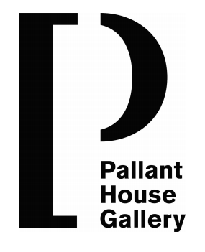

Patrons
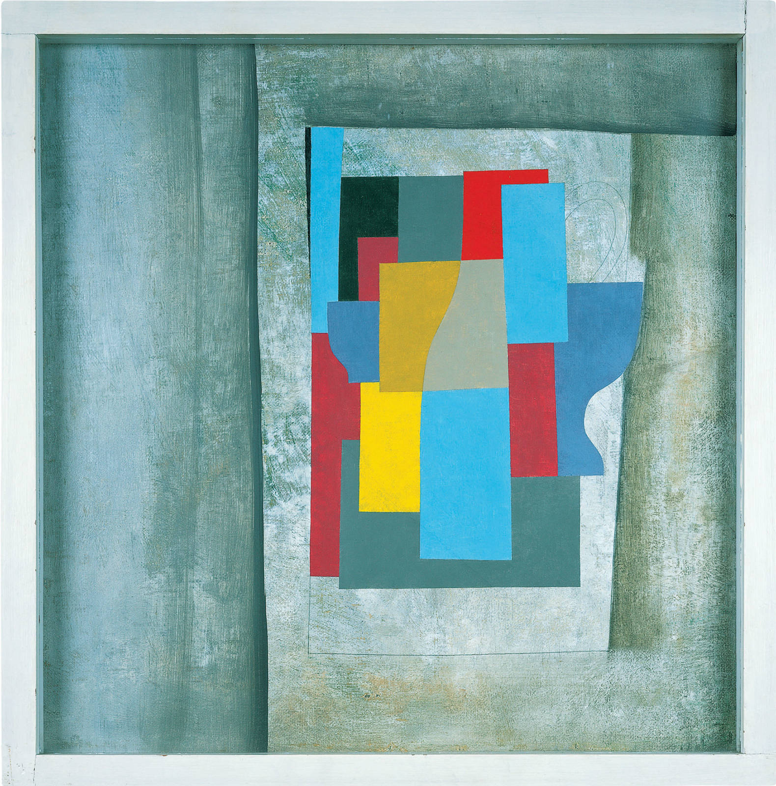

Become a Patron today and help secure the future of British Modern Art
Join as a patron and get a closer relationship to the collections, curators, and artists of Pallant House Gallery.

Patrons make a vital contribution to key projects, new exhibitions, and core running costs. Be a part of our exhibitions supporter circles, yearly art trips, and more.

Image on front cover: Ben Nicholson (1946) Still Life - Cerulean

Our values
We are one of Britain's most distinctive modern art museums. Our world-class collection tells the story of Modern British art from 1900 to now, held within the unique setting of a Grade I listed 18th century townhouse and a 21st century contemporary extension.

“The brilliance of Pallant House Gallery lies not only in its thoughtful and intelligent curation but in the warmth and welcome of the building. The way this fine collection is displayed is intimate yet with space for reflection and tranquillity.”
Francine Stock, broadcaster and novelist

We explore new perspectives on British art from 1900 to now through an ambitious programme of exhibitions and creative opportunities for all. Our mission is to share and stimulate new thinking on British art and to play a pivotal role in the creative lives of the widest possible audience.

From Post-Impressionism to Cubism, Neo-Romanticism to Pop and Neo-classicism to contemporary art, our collections and exhibitions tell the story of Britain through the eyes of some of the most important British artists, including Keith Vaughan, Ben Nicholson, Ivon Hitchens, Edward Burra, Graham Sutherland and Barbara Hepworth.

Patrons are vital in helping to

Fund exhibitions with our supporters' circles

We couldn’t put on exhibitions without our supporters' circles. Patrons are a vital part of bringing British Modern Art to the public - an exhibition can cost anything up to £130,000 and Patronages help make that possible.

Enable learning opportunities

Through the support of funders we are able to host a variety of practical and social learning programmes. From artist-led educational sessions to talks and symposiums, from school group visits to the Arts Awards programme; Patrons are key supporters of learning.

Help conserve works of art

Patron’s often take part in important conservation campaigns to help restore damaged or long-ignored works of art. In one recent example, money was raised to conserve Christopher Wood’s China Dogs in a St Ives Window, allowing us to rescue a deeply damaged work and bring it back to life.

Patronages
Patronages are split into three tiers of giving, and offer the following benefits:

Patron
£1200 per year or £100 per month by Direct Debit (£500 actual value, £700 donation)
- Unlimited admission to the Gallery to view the Permanent Collection and temporary exhibitions for you and a family member
- Invitations to Private Views for you and a guest each new exhibition
- Invitations to private tours for new exhibitions
- Invitation to join the yearly Art Trips, with VIP access to private collections around the world (additional cost applies)
- Acknowledgement of support on the Gallery website unless you wish to remain anonymous

Silver
£2500 per year or £208.33 per month by Direct Debit (£700 actual value, £1800 donation)
Patron plus:
- Exclusive access to the Gallery’s permanent Collection with private tour with a Curator or Conservator on a special subject of interest to you and your guests
- Private tours of our exhibitions
- Complimentary exhibition catalogue for our temporary exhibitions
- Invitation to Director’s Annual Lunch

Gold
£5000 per year or £416.66 per month by Direct Debit (£1000 actual value, £4000 donation)
Silver plus:
- Acknowledgement of support on the gallery wall
- Education workshop provided by the Gallery’s Public Programmes team for a school group of your choice
- Priority booking and discount on private hire of the gallery spaces and the Pallant Restaurant
- Invite to the Private View dinners
If you would like to become a Patron simply fill out the attached form below and return it to Pallant House Gallery, marked c/o Leo Powell (Patrons), or simple return it via email to l.powell@pallant.org.uk

Patron Programme

Become a Patron to enjoy great benefits at the Gallery, including regular trips and studio visits as well as the chance to meet others who share a passion for the arts.

Our Patrons provide vital support that enables us to care for our world class collection, create original exhibitions and grow our pioneering public programmes. Benefits include exhibition previews, curator-led events, visits to other art institutions and organisations internationally [costs apply), VIP tickets to National art fairs, Acknowledgement at the gallery, online and in our annual review.

I would like to join as a Patron at the level of the following:

Patron

[ ) Monthly Direct Debit [£100 per month)
[ ) Annual Direct Debit [£1200 per year)
[ ) Annually via BACS or Cheque [£1200 per year)

Silver Patron

[ ) Monthly Direct Debit [£208.33 per month)
[ ) Annual Direct Debit [£2500 per year)
[ ) Annually via BACS or Cheque [£2500 per year)

Gold Patron

[ ) Monthly Direct Debit [£416.66 per month)
[ ) Annual Direct Debit [£5000 per year)
[ ) Annually via BACS or Cheque [£5000 per year)

Your details:

Full name and address ___________________________________
___________________________________
___________________________________

Email address ___________________________________

Your email address is used for internal communications only and will never be given to any external party.

Name to be acknowledged in the following format:

___________________________________________

Or I wish to remain anonymous [ )

Signature ______________________ Date __________
You can pay by cheque, Direct Debit or BACS to Pallant House Gallery. For Direct Debit simply return the form below, alternatively you may use the following;

Sort code: 20-20-62
Account no 60596043

with the narration ‘Patronage’

Please return this form to Leo Powell, Development Officer via post marked Patrons, or simply email a copy to l.powell@pallant.org.uk

Thank you

If you are a UK Taxpayer your patronage can earn even more for Pallant House Gallery, at no extra cost to you.

Thank you. I would like to gift aid any donations I make in the future or have made in the past four years to support the work of Pallant House Gallery. I am a UK taxpayer and understand that if I pay less Income Tax and/or Capital Gains Tax than the amount of Gift Aid claimed on all my donations in that tax year it is my responsibility to pay any difference. I will notify Pallant House Gallery if I want to cancel this declaration, change my name or home address or no longer pay sufficient tax on my income and/or capital gains.

Signature ___________________________ Date ___________

Direct Debit form

Name(s) of account holder(s) _________________________________________

Your Bank/Building Society ___________________________________________

Account Number _________________ Sort Code _________________

Direct debits will be taken on the 1st of each month.

Instructions to your Bank or Building Society: Please pay Pallant House Gallery Direct Debits from the account detailed in this instruction subject to the safeguards assured by the Direct Debit guarantee. I understand that details may remain with Pallant House Gallery and if so, details will be passed electronically to my bank or building society.

Signature ______________________________________ Date _____________

DIRECT DEBIT GUARANTEE This guarantee is offered by all banks and building societies that accept instructions to pay by Direct Debits. • If there are any changes to the amount, date or frequency of your Direct Debit, Pallant House Gallery will notify you 10 working days in advance of your account being debited or as otherwise agreed. If you request Pallant House Gallery to collect payment, confirmation of the amount and date will be given to you at the time of your request. • If an error is made in the payment of your Direct Debit, by Pallant House Gallery or your bank or building society, you are entitled to a full and immediate refund from your bank or building society. • If you receive a refund you are not entitled to, you must pay it back when Pallant House Gallery asks you to. • You can cancel a Direct Debit at any time by simply contacting your bank or building society. Written confirmation may be required. Please notify Pallant House Gallery.

